
Supply Chain Logistics Network and Delivery Performance Visualization Platform
A CAPSTONE PROJECT REPORT
A Capstone Project Report submitted in partial fulfilment of the requirements for the Course of
DSA0601-DATAHANDLING AND VISUALIZATION
to the award of the degree of
BACHELOR OF TECHNOLOGY
IN
COMPUTER SCIENCE AND ENGINEERING
Submitted by
K. Saisomasekhar Reddy (192324134)
Under the Supervision of
Dr. S. SENTHILVADIVU
SIMATS ENGINEERING
Saveetha Institute of Medical and Technical Sciences
Chennai-602105
AUGUST 2026

SIMATS ENGINEERING
Saveetha Institute of Medical and Technical Sciences
Chennai-602105
BONAFIDE CERTIFICATE
This is to certify that the Capstone Project entitled “Supply Chain Logistics Network and Delivery Performance Visualization Platform” has been carried out by K. Saisomasekhar Reddy (192324134) under the supervision of Dr. S. SENTHILVADIVU and is submitted in partial fulfilment of the requirements for the current semester of the B.Tech Computer Science and Engineering program at Saveetha Institute of Medical and Technical Sciences, Chennai.
COURSE COORDINATOR  Title / Name,  Designation  Computer Science and Engineering  SIMATS Engineering,  SIMATS, Chennai – 602105. | COURSE FACULTY  Dr. S. SENTHILVADIVU  PROFESSOR  Computer Science and Engineering  SIMATS Engineering,  SIMATS, Chennai – 602105.

SIMATS ENGINEERING
Saveetha Institute of Medical and Technical Sciences
Chennai-602105
DECLARATION
We, K. Saisomasekhar Reddy (192324134), of the Computer Science and Engineering Department, Saveetha Institute of Medical and Technical Sciences, Saveetha University, Chennai, hereby declare that the Capstone Project Work entitled “Supply Chain Logistics Network and Delivery Performance Visualization Platform” is the result of our own bonafide efforts. To the best of our knowledge, the work presented herein is original, accurate, and has been carried out in accordance with the principles of engineering ethics.
Place: Chennai
Date: __________________

Signature of the Student with name
K. Saisomasekhar Reddy (192324134)

SIMATS ENGINEERING
Saveetha Institute of Medical and Technical Sciences
Chennai-602105
Individual Contribution Statement
(Mandatory for all team projects)
Student Name / Register No. | Specific Responsibilities | Design & Development Contribution | Testing & Analysis Contribution | Report Contribution | Approx. Contribution (%)
K. Saisomasekhar Reddy (192324134) | Joint project responsibilities; individual allocation not separately specified in source. | Data integration / network modelling / dashboard work as applicable to the joint project. | Testing and analysis as applicable to the joint project. | Sections contributed across the report.
K. Kiran (192324205) | Joint project responsibilities; individual allocation not separately specified in source. | Data integration / network modelling / dashboard work as applicable to the joint project. | Testing and analysis as applicable to the joint project. | Sections contributed across the report.
K. C. Revi Thimma Reddy (192325025) | Joint project responsibilities; individual allocation not separately specified in source. | Data integration / network modelling / dashboard work as applicable to the joint project. | Testing and analysis as applicable to the joint project. | Sections contributed across the report.
Total |  |  |  |  | 100%

Note: The source report does not provide an individual percentage or a student-by-student responsibility breakdown; therefore no unsupported allocation has been added.

ABSTRACT
Efficient supply chain management depends on the ability to track shipments, measure delivery performance, and respond quickly to disruptions across a distributed logistics network. However, many logistics operations still rely on fragmented spreadsheets, delayed status updates, and manual reporting, which make it difficult to identify bottlenecks or predict late deliveries before they affect customers. This project proposes a Supply Chain Logistics Network and Delivery Performance Visualization Platform that consolidates shipment, route, and warehouse data into a single system and presents it through an interactive dashboard. The system is structured into two major modules. Module 1: Logistics Data Integration and Network Modelling, focuses on collecting shipment and route data from carriers, warehouses, and order-management systems, cleaning and structuring it, and representing the distribution network as a graph of nodes (warehouses, hubs, delivery points) and edges (routes) so that transit times and route efficiency can be analyzed systematically. Module 2: Delivery Performance Analytics and Visualization Dashboard, computes key performance indicators such as on-time delivery rate, average transit time, delay frequency by route, and damage/return rate, and presents them through interactive charts, a network map, and configurable alerts. By combining network modelling with real-time performance analytics, this project helps logistics managers identify underperforming routes and carriers, anticipate delays, and make data-driven decisions that improve delivery reliability and reduce operating costs.
Keywords: Supply Chain Logistics, Network Modelling, Delivery Performance, KPI Analytics, Data Visualization, Route Analysis

TABLE OF CONTENTS
Sl. No. | Title | Page No.
i | CERTIFICATE FROM THE SUPERVISOR | 3
ii | DECLARATION BY THE CANDIDATE | 4
iii | INDIVIDUAL CONTRIBUTION STATEMENT | 5
iv | ABSTRACT | 6
v | LIST OF FIGURES | 8
vi | LIST OF TABLES | 9
vii | LIST OF ABBREVIATIONS / SYMBOLS | 10
1 | CHAPTER 1: Introduction and Engineering Problem | 11
2 | CHAPTER 2: Literature Review and Existing Solutions | 13
3 | CHAPTER 3: Engineering Design & Trade-offs, Sustainability, Ethics, Safety, Risk & Security | 14
4 | CHAPTER 4: Implementation, Testing & Results, Project Management | 17
5 | CHAPTER 5: Conclusion, Future Work and Reflection | 21
 | References | 22
 | Appendices | 23

LIST OF FIGURES
Figure No. | Figure Name | Page No.
1 | Performance by Hub and Delivery Delay Rate | 17
2 | Delivery Performance Analytics | 18
3 | Supply Network Association | 19

LIST OF TABLES
Table No. | Table Name | Page No.
1 | Comparison with Existing Approaches | 13
2 | Tools and Technologies Used | 14
3 | Sample KPI Output | 18
4 | Sample Shipment Data | 23
5 | KPI Definitions | 23
6 | Tools and Technologies | 23
7 | Route Performance Threshold Table | 23

LIST OF ABBREVIATIONS / SYMBOLS
Symbol | Description | Unit
API | Application Programming Interface | —
BI | Business Intelligence | —
CI/CD | Continuous Integration / Continuous Deployment | —
KPI | Key Performance Indicator | —
SLA | Service Level Agreement | —
TLS/SSL | Transport Layer Security / Secure Sockets Layer | —

CHAPTER 1
INTRODUCTION AND ENGINEERING PROBLEM

1.1 Background
Modern supply chains span multiple warehouses, carriers, and delivery routes, and their performance directly affects customer satisfaction and operating cost. As e-commerce and distributed retail grow, logistics networks generate large volumes of shipment and tracking data, but this data is often scattered across carrier portals, warehouse management systems, and spreadsheets. Without a unified view, logistics teams struggle to answer which routes are consistently late, which carriers under-perform, and where bottlenecks are forming in the network.
Graph-based network modelling, combined with real-time performance analytics, offers a practical way to represent a distribution network and quantify how well it is performing. Integrating this with an interactive visualization dashboard allows logistics managers to monitor delivery performance continuously and intervene before minor delays become major service failures.
Historically, logistics visibility relied on periodic manual status calls to carriers and end-of-day spreadsheet reconciliation. This approach does not scale as network size grows and introduces a lag between an event occurring in the field and that event becoming visible to decision-makers. The proposed platform narrows this lag by continuously ingesting shipment events, updating the network model, and recomputing performance indicators.

1.2 Need for the Project
- Fragmented shipment, route, and warehouse data makes network-wide comparison difficult.
- Inconsistent status codes and timestamp formats increase reconciliation effort and error risk.
- Reactive reporting delays identification of poorly performing routes and carriers.
- Fast and reliable delivery expectations make timely visibility important for logistics operations.

1.3 Problem Statement
The engineering problem is the absence of a consolidated system that can integrate logistics data from multiple sources, model the distribution network, compute standardized delivery performance metrics, and present them through a real-time visualization dashboard to support proactive supply chain decisions.

1.4 Project Aim
To develop a Supply Chain Logistics Network and Delivery Performance Visualization Platform that combines data integration, graph-based network modelling, delivery KPI analytics, and interactive visualization for proactive logistics decision-making.

1.5 Project Objectives
- Design a data integration pipeline that consolidates shipment, route, and warehouse data into a single structured dataset.
- Model the distribution network as a graph of warehouses, hubs, and delivery points connected by routes.
- Compute on-time delivery rate, average transit time, delay frequency, and damage/return rate.
- Build an interactive dashboard displaying the logistics network map, performance trends, and alerts.
- Support data-driven decisions for route planning, carrier evaluation, and warehouse resource allocation.

1.6 Scope
1.6 PROJECT VISUAL:
The project focuses on modelling a logistics distribution network and visualizing delivery performance. It includes data integration from shipment and route records, network modelling of warehouses and delivery routes, and computation of standard delivery KPIs. A web-based dashboard is developed for logistics managers and analysts. The scope is limited to network-level and route-level performance visualization; vehicle-level telematics, last-mile driver scheduling, and full warehouse inventory management are outside the stated scope and are treated as future extensions.

1.7 Expected Engineering Outcome
The intended outcome is a web-based platform comprising a data integration pipeline, a graph-based supply network model, a KPI analytics engine, an interactive dashboard, and configurable alerts for underperforming routes or carriers.

1.8 Assumptions and Constraints
- Carrier and warehouse systems can provide shipment status updates at least once per hour through an API or scheduled export.
- Route distances and historical transit times are available or can be estimated from geocoded warehouse/delivery-point addresses.
- The platform depends on the timeliness and accuracy of upstream carrier data and cannot correct for a carrier that fails to report a status update.
- Initial scope covers domestic, ground-based delivery routes; multimodal air/sea legs are future extensions.

CHAPTER 2
LITERATURE REVIEW AND EXISTING SOLUTIONS

2.1 Review Method
The source report draws on industry studies, research on logistics visibility, delivery-performance analytics, and graph-based network analysis. It also compares common operational approaches such as spreadsheet reporting, single-carrier tracking portals, and generic BI dashboards with the proposed platform.

2.2 Review of Existing Work
Existing logistics visibility approaches include manual spreadsheet reporting, carrier-specific tracking portals, and generic business-intelligence dashboards. These approaches provide useful capabilities but do not provide the same combination of cross-carrier visibility, network/graph modelling, standardized KPIs, and proactive alerts described in the proposed platform.

2.3 Comparative Analysis
Existing Approach | Advantages | Limitations | Relevance to Proposed Work
Manual spreadsheet reporting | Low cost; no new infrastructure | Slow; error-prone; no real-time visibility | Motivates automated integration and dashboards
Single-carrier tracking portals | Accurate for that carrier’s shipments | No cross-carrier or network-wide view | Shows need for unified multi-source visibility
Generic BI dashboards on raw data | Flexible reporting | No native network/graph model of routes and hubs | Shows value of a domain-specific graph model
Proposed platform | Unified network model + real-time KPIs across carriers | Depends on timely data feeds from all sources | Selected approach

2.4 Research / Engineering Gap
The unresolved gap identified in the source is the lack of a consolidated system that integrates fragmented logistics records, represents the distribution network structurally, computes standardized route and carrier KPIs, and exposes those insights through a real-time visualization dashboard.

2.5 Proposed Contribution
The proposed contribution is a modular platform combining logistics data integration, graph-based network modelling, performance analytics, visualization, and threshold-based alerts. The architecture is intended to be extendable to predictive delay models and route optimization.

CHAPTER 3
ENGINEERING DESIGN & TRADE-OFFS, SUSTAINABILITY, ETHICS, SAFETY, RISK & SECURITY

3.1 Requirements
Stakeholder / User Requirements
Stakeholder | Requirement
Logistics Managers | Actionable visibility into route and carrier performance
Warehouse Operations Teams | Network insights for dispatch scheduling and resource allocation
Carriers and Delivery Partners | Clear, objective performance feedback
Customers | More reliable delivery estimates and fewer missed deliveries
Supply Chain Analysts | Performance data for structural network improvement

Functional & Non-Functional Requirements
Requirement | Type | Measurable Target
Data integration | Functional | Consolidate shipment, route and warehouse data
Network modelling | Functional | Represent locations as graph nodes and routes as weighted edges
KPI computation | Functional | Compute on-time rate, transit time, delay frequency and damage/return rate
Dashboard visualization | Functional | Display network map, KPI trends and comparisons
Alerts | Functional | Flag routes/carriers crossing configured thresholds
Refresh | Non-Functional | Source data updates at least once per hour (assumption)
Security | Non-Functional | TLS/SSL transmission and role-based access control

3.2 Constraints & Applicable Standards
Standard / Code | Requirement | How Applied in This Project
TLS/SSL | Secure data transmission | Specified for data transmission
Git / CI/CD practices | Version control and continuous integration/deployment | Used for software engineering workflow
Semantic versioning | Version identification | Specified in project engineering practices
Accessible visualization | Color-blind-safe visual cues | Specified for dashboard alerts
Specific formal standards | Not named in source | No unsupported standard added

3.3 Design Specifications
Parameter | Target/Requirement | Unit | Priority
Status update interval | At least once per hour | hour | High
On-time KPI | Computed per route/carrier/region | % | High
Average transit time | Computed per route/carrier/region | time | High
Delay frequency | Computed and threshold-checked | % | High
Network model | Directed weighted graph | — | High
Dashboard | Interactive map + trends + alerts | — | High

3.4 Alternative Solutions & Evaluation
Alternative 1: Manual spreadsheet reporting is low cost and requires no new infrastructure, but it is slow and does not provide real-time visibility.
Alternative 2: Single-carrier tracking portals provide accurate carrier-specific tracking but lack a cross-carrier network-wide view.
Alternative 3: Generic BI dashboards are flexible but do not natively model logistics routes and hubs as a graph.
Criterion | Weight | Alternative 1 | Alternative 2 | Alternative 3
Performance | Not specified | Low | Medium | Medium
Cost | Not specified | Low | Medium | Medium
Safety | Not specified | Not specified | Not specified | Not specified
Sustainability | Not specified | Not specified | Not specified | Not specified
Reliability | Not specified | Low | High (carrier-specific) | Medium

3.5 Selected Design & Detailed Design
The proposed platform is selected because it directly addresses the identified gap by unifying multi-source logistics data, modelling the network as a graph, computing comparable KPIs, and presenting actionable results through a dashboard. The source report identifies modularity and scalability as additional advantages.
Architecture / Data Flow
Order/Warehouse Systems + Carrier Data → Ingestion → Preprocessor → Structured Storage (relational + graph) → Analytics Engine → Dashboard + Alert System
Key engineering calculations
Dijkstra shortest-path relation: d(v) = min[d(u) + w(u,v)] for each edge (u,v), where d(v) is the shortest known transit time to node v, d(u) is the shortest known transit time to node u, and w(u,v) is the edge transit-time weight.
On-time Delivery Rate = (shipments delivered on or before promised time / total shipments) × 100. Average Transit Time = sum of (delivery time − dispatch time) / number of shipments. Delay Frequency = (shipments exceeding expected transit time / total shipments on route) × 100. Damage/Return Rate = (damaged or returned shipments / total shipments delivered) × 100.
Systems approach: The ingestion layer collects source records and the preprocessing layer cleans, deduplicates, and normalizes them. Structured relational and graph storage support both record-level and network-level analysis. The analytics engine computes route, carrier, and regional KPIs and flags threshold breaches. The visualization layer exposes the results through maps, charts, comparisons, and alerts.

3.6 Trade-off Analysis
Design Decision | Alternative Considered | Benefit | Disadvantage | Final Decision & Justification
Unified data model | Manual spreadsheets | Single consistent view | Depends on upstream feeds | Selected; addresses fragmentation
Graph-based network model | Generic BI dashboard | Natural route/hub representation | Requires graph computation | Selected; supports bottleneck analysis
Modular dashboard architecture | Single monolithic system | Scalable and extendable | More components to integrate | Selected; supports future additions

3.7 Sustainability, Ethics, Safety, Risk & Security
Domain | Consideration | Evidence Evaluated | Impact on Final Decision
Sustainability | No specific sustainability measure stated | Not provided in source | No specific design change documented
Ethics | Accuracy, transparent metrics, responsible data use | Engineering ethics statement in source | Supports reliable and transparent KPI reporting
Health & Safety | No specific safety case stated | Not provided in source | No specific design change documented
Security | Protect shipment/customer data | TLS/SSL; role-based access; least privilege | Security controls specified in architecture

Risk Register
Risk | Likelihood | Severity | Risk Level | Mitigation | Residual Risk
Data inconsistency | Not specified | Not specified | Not specified | Normalize status codes and timestamps | Not specified
Missing tracking records | Not specified | Not specified | Not specified | Validate missing timestamps/records | Not specified
Network computation complexity | Not specified | Not specified | Not specified | Optimize graph computations | Not specified
Real-time synchronization | Not specified | Not specified | Not specified | Scheduling and caching | Not specified

CHAPTER 4
IMPLEMENTATION, TESTING & RESULTS, PROJECT MANAGEMENT

4.1 Development Approach & Resources
The development approach follows requirements definition, data ingestion and preprocessing, graph-based network modelling, KPI analytics, dashboard development, and testing/validation. The source report describes unit tests for the analytics engine, integration tests for the data pipeline, and validation against historical shipment records.

4.2 Hardware / Software / Fabrication Implementation & Modern Tools Used
Tool / Software / Equipment | Purpose | Stage Used
Python (FastAPI/Flask) or Node.js | Backend/API | Implementation
PostgreSQL | Relational shipment records | Data storage
Neo4j / NetworkX | Graph/network modelling | Network modelling
Pandas / NumPy | KPI computation | Analytics
React + D3.js / Recharts | Dashboard visualization | Visualization
Git, Docker, GitHub Actions | Version control, deployment and CI | Development / deployment

Implementation evidence: the source report contains dashboard output visuals reproduced below.
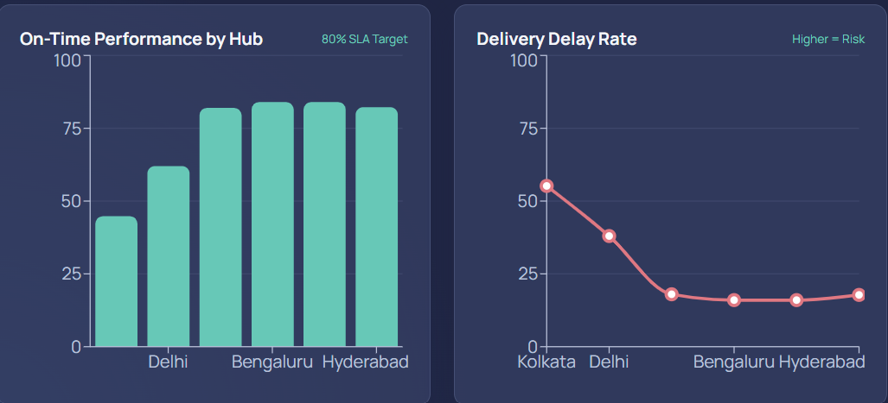
Figure 1. Performance by Hub and Delivery Delay Rate.

4.3 Test Plan & Verification
Requirement | Test Method | Acceptance Criterion
Data pipeline | Integration testing with source records | Records cleaned, normalized and stored
Analytics engine | Unit tests + sample shipment datasets | KPIs computed and delay thresholds flagged
Network model | Validation against route/hub structure | Nodes and weighted routes represented correctly
Dashboard | Functional validation | Network map and KPI views update within target latency

Specification | Required Value | Achieved Value | Status (Pass/Fail)
Delay threshold | Configured threshold | Routes above threshold were flagged | Pass (sample)
KPI view latency | Target specified in requirements | Dashboard updated within target latency | Pass (sample)

4.4 Results
Testing with sample shipment datasets showed that the platform could reliably flag routes with delay rates above the configured threshold, and the dashboard updated KPI views within the target latency. The network-and-analytics approach therefore demonstrated effectiveness for delivery performance monitoring in the sample evaluation.
Route | On-time Rate | Avg. Transit Time | Delay Frequency
Warehouse A → Hub 1 | 96% | 3.4 hrs | 4%
Warehouse A → Hub 2 | 82% | 5.9 hrs | 18%
Hub 1 → Delivery Point 5 | 94% | 2.1 hrs | 6%
Hub 2 → Delivery Point 9 | 88% | 4.2 hrs | 12%

Table 3. Sample KPI Output
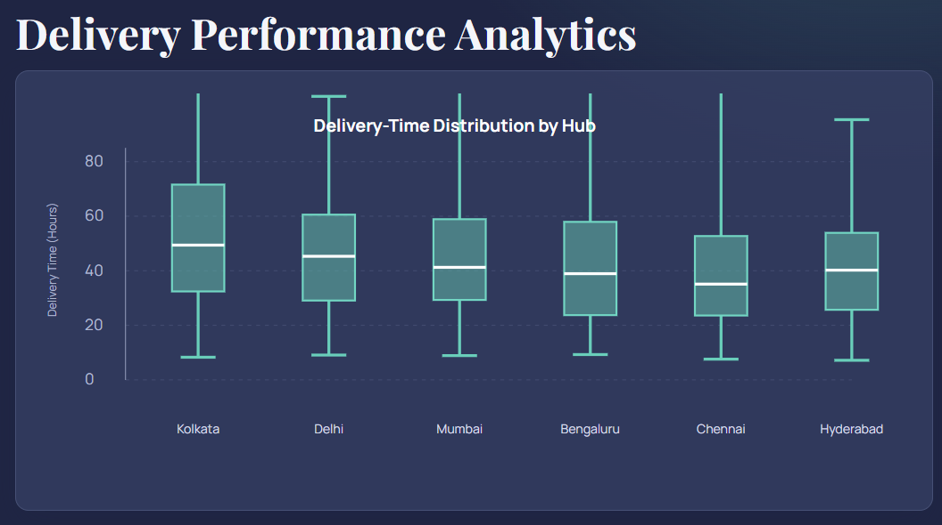
Figure 2. Delivery Performance Analytics.
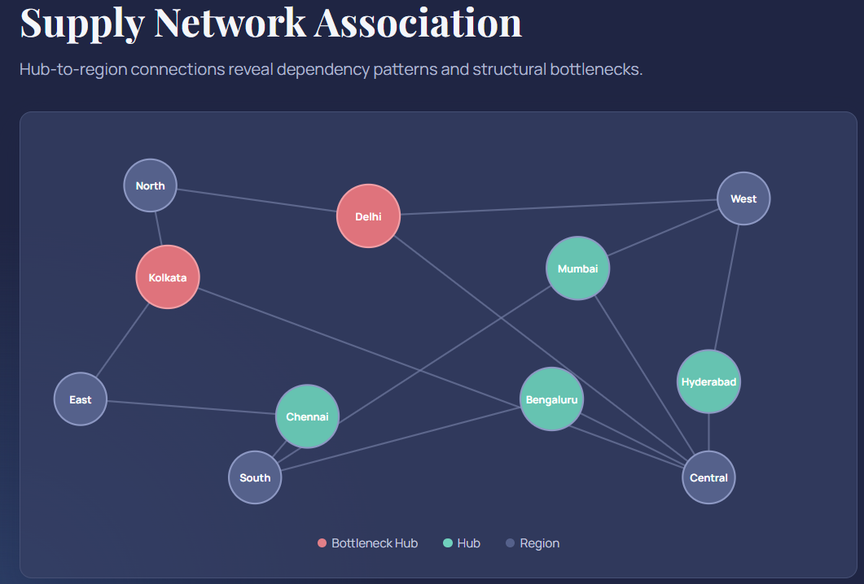
Figure 3. Supply Network Association.

4.5 Data Analysis & Engineering Judgment
The Warehouse A → Hub 2 route has the lowest on-time rate (82%) and the highest delay frequency (18%) in the sample, making it the clearest route for investigation. The network visualization also highlights hub and regional dependency patterns. The source identifies data inconsistency, missing records, network complexity, and synchronization as practical engineering challenges.

4.6 Comparison with Existing Solutions & Achievement of Objectives
Objective | Evidence | Achievement (Fully/Partially/Not Achieved)
Consolidate logistics data | Structured network model and ingestion pipeline | Fully
Model distribution network as a graph | Nodes, weighted routes, graph modelling and network visualization | Fully
Compute delivery KPIs | On-time rate, transit time and delay frequency outputs | Fully
Build interactive visualization dashboard | Network map, KPI trends and alerts | Fully
Support data-driven decisions | Underperforming route identification and recommendations | Fully

4.7 Strengths & Limitations
Strengths:
- Unified view of shipment, route, and warehouse data.
- Graph-based representation supports route and bottleneck analysis.
- Standardized KPIs enable route and carrier comparison.
- Modular architecture supports future extension.
Limitations:
- Dependent on timely and accurate upstream carrier data.
- Missing tracking records can limit transit-time computation.
- Graph computation may require optimization as network size grows.
- Initial scope is limited to domestic, ground-based routes.

4.8 Project Planning, Roles & Budget
The source report does not provide a Gantt chart, dated milestone schedule, individual role allocation, or cost figures. These items are therefore recorded as not specified rather than invented.
Student | Assigned Responsibility | Actual Contribution
K. Saisomasekhar Reddy | Not specified individually | Joint project contribution
K. Kiran | Not specified individually | Joint project contribution
K. C. Revi Thimma Reddy | Not specified individually | Joint project contribution

Item | Estimated Cost | Actual Cost
Project resources | Not specified | Not specified

CHAPTER 5
CONCLUSION, FUTURE WORK AND REFLECTION

5.1 Conclusion
The project “Supply Chain Logistics Network and Delivery Performance Visualization Platform” demonstrates how consolidating fragmented logistics data into a structured network model, combined with a real-time analytics dashboard, can improve visibility into delivery performance. By integrating shipment, route, and warehouse data with graph-based network modelling, the system enables logistics managers to identify underperforming routes and carriers before they escalate into customer-facing problems. The project therefore combines network modelling, data analytics, and visualization to support more reliable, cost-effective, and customer-centric supply chain operations.

5.2 Future Work
- Predictive delay modelling using historical patterns and external factors such as weather and traffic.
- Route optimization and load-balancing recommendations.
- Automated anomaly detection for incoming shipment records.
- Historical carrier scorecards for contract negotiation support.
- Warehouse dwell-time and inventory-turnover integration.
- Multimodal air/sea route support.

5.3 Professional Learning & Individual Reflection
New Knowledge Acquired:
- Practical understanding of graph-based logistics network modelling.
- Data integration and cleaning across inconsistent sources.
- Design and computation of meaningful operational KPIs.
- Integration of data ingestion, analytics, and visualization layers.
- Dashboard design for decision-support use cases.
Engineering & Professional Skills Developed:
- Data pipeline design, graph algorithms, dashboard development, systems integration, and engineering judgment.
- Application of engineering ethics through accurate data handling, transparent metrics, and responsible use of shipment and carrier data.
Individual Reflection:
The source report provides a collective reflection rather than separate 4–5-line reflections for each student. It identifies the main engineering difficulties as reconciling inconsistent data formats, balancing graph-computation complexity with dashboard responsiveness, and designing KPI thresholds that remain meaningful across route types. It also states that developing the platform strengthened data integration, algorithm design, and dashboard development skills.

5.4 Industry Insights
- Growing reliance on real-time visibility platforms in distributed supply chains.
- Increasing use of data analytics and network modelling for logistics decisions.
- Demand for scalable, low-overhead solutions for smaller operations.
- Movement toward predictive analytics and route optimization.

5.5 Conclusion of Development
Developing this platform was a valuable exercise in applying network modelling and data analytics to a real operational problem. Combining a graph-based representation of the distribution network with a performance analytics engine and visualization dashboard demonstrated how disparate logistics data can be turned into actionable insight. The process strengthened skills in data integration, algorithm design, and dashboard development, and reinforced the practical importance of reliable, well-structured data in supply chain decision-making.
REFERENCES
- Chopra, S., & Meindl, P. (2022). Supply Chain Management: Strategy, Planning, and Operation. Pearson Education.
- Christopher, M. (2021). Logistics and Supply Chain Management. FT Publishing International.
- Ivanov, D., Tsipoulanidis, A., & Schönberger, J. (2021). Global Supply Chain and Operations Management: A Decision-Oriented Introduction to the Creation of Value. Springer.
- Newman, M. E. J. (2018). Networks: An Introduction. Oxford University Press.
- Handfield, R. B., & Nichols, E. L. (2020). Introduction to Supply Chain Management. Prentice Hall.
- Research articles on real-time logistics visibility platforms and delivery performance analytics (industry white papers and journal preprints, 2023–2025).
- Cormen, T. H., Leiserson, C. E., Rivest, R. L., & Stein, C. (2022). Introduction to Algorithms (4th ed.). MIT Press.
- Simchi-Levi, D., Kaminsky, P., & Simchi-Levi, E. (2021). Designing and Managing the Supply Chain: Concepts, Strategies, and Case Studies. McGraw-Hill.
- Council of Supply Chain Management Professionals (CSCMP). (2024). State of Logistics Report.
APPENDICES

Appendix A – System Architecture Overview
MODULE 1: Logistics Data Integration and Network Modelling
Shipment/Route Data Sources → Data Ingestion → Cleaned Shipment Data → Network Graph Construction (Warehouses, Hubs, Delivery Points, Routes)
MODULE 2: Delivery Performance Analytics and Visualization Dashboard
Network Model → KPI Computation (On-time Rate, Transit Time, Delay Frequency, Damage Rate) → Visualization Dashboard → Alerts

Appendix B – Sample Shipment Data
Shipment ID | Route | Dispatch Time | Delivery Time | Status
SC-1001 | Warehouse A → Hub 1 | 08:00 AM | 11:20 AM | On Time
SC-1002 | Warehouse A → Hub 2 | 08:15 AM | 01:40 PM | Delayed
SC-1003 | Hub 1 → Delivery Point 5 | 12:00 PM | 02:10 PM | On Time
SC-1004 | Hub 2 → Delivery Point 9 | 02:00 PM | Missing | In Transit

Appendix C – Key Performance Indicator Definitions
KPI | Definition
On-time Delivery Rate | Percentage of shipments delivered on or before the promised delivery time
Average Transit Time | Mean time elapsed between dispatch and delivery for a route or carrier
Delay Frequency | Proportion of shipments on a route exceeding the expected transit time
Damage/Return Rate | Percentage of shipments reported damaged or returned

Appendix D – Tools and Technologies
Category | Tools/Technologies Used
Data Sources | Order management exports, carrier tracking APIs, warehouse system records
Backend | Python (FastAPI/Flask) or Node.js
Database | PostgreSQL, Neo4j / NetworkX for graph modelling
Visualization | React, D3.js / Recharts, network-graph library
Deployment | Docker, cloud hosting, CI/CD (GitHub Actions)

Appendix E – Route Performance Threshold Table
Route Type | Target On-time Rate | Alert Threshold
Regional (< 100 km) | ≥ 95% | < 90%
Intercity (100–500 km) | ≥ 90% | < 85%
Long-haul (> 500 km) | ≥ 85% | < 80%

Appendix F – Glossary of Terms
Term | Meaning
Node | A location in the network graph — a warehouse, hub, or delivery point
Edge | A route connecting two nodes, weighted by distance and/or transit time
Hub | An intermediate consolidation/transfer point between warehouses and delivery points
Dwell Time | Time a shipment spends sitting at a warehouse or hub before onward movement
SLA | Service Level Agreement — the promised delivery time/performance commitment

